**Task 1**

I have tried to change some numbers in the matrix to change the 8 to 5

Then I noticed that if we changed the positions [3,0] and [1,2] to the yellow color it will form the shape of number 5

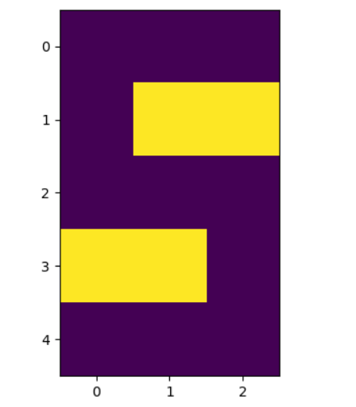

**Task 2**

Here I used the matplot library to read and display the image, numpy for manipulate the image.

I created a copy of the image we want to manipulate so that it remains without any changes because I had some problems when I didn’t create a copy of the original image.

I used “2” in the color channel which is Blue

I searched on google and I found out that number “3” represents “Alpha”, the transparency color.

I could’ve used “3” in the color channel as transparency color, but in the output example in the word file it was like this, and the instructor told me that this is correct

Finally, matplot will show the edited image, and the last line will save the image to the desired path.

